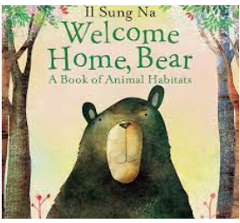

Term 6:

Animals- Exploring habitats & different environments

**Learning Through Talk (3-4 Yrs)**

-Talk about the differences between different countries and habitats

Follow simple story maps

Begin to understand the need to care for the natural environment

**Supporting Texts:**

*Little People Series: Greta Thunberg*

*Tidy*

**Learning Through Talk (Reception)**

**-**Describe different habitats and environments using new vocabulary

-Design and record using simple story maps

-Recognise that some environments are different to the one they live in

-Discuss how we can care for the natural world

**Learning To Talk**

-

-

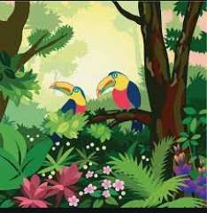

**Collections/Displays:** Pictures of Non Fiction Books about different environments

**Real Experiences:** Handling Spiders/Bugs from rainforest

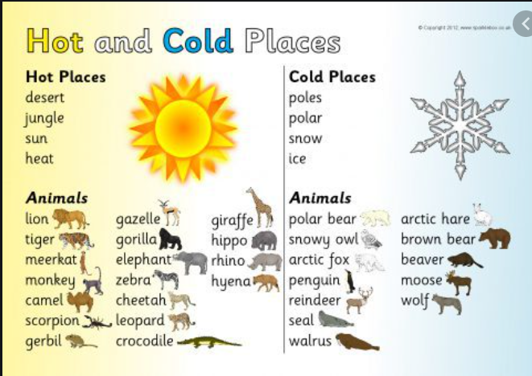

***Vocabulary***

***Habitat***

***Rainforest***

***Desert***

***Polar Lands***

***Ocean***

***Nest***

***Burrow***