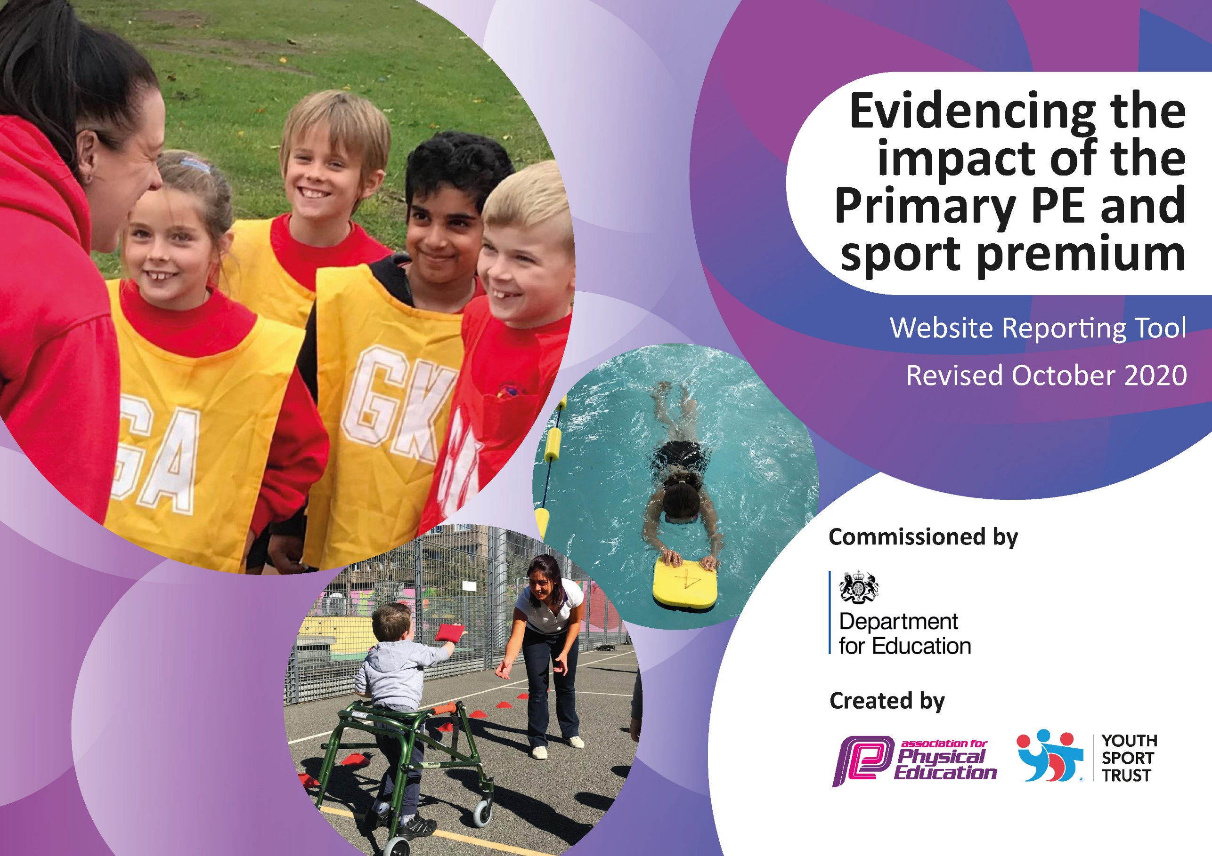
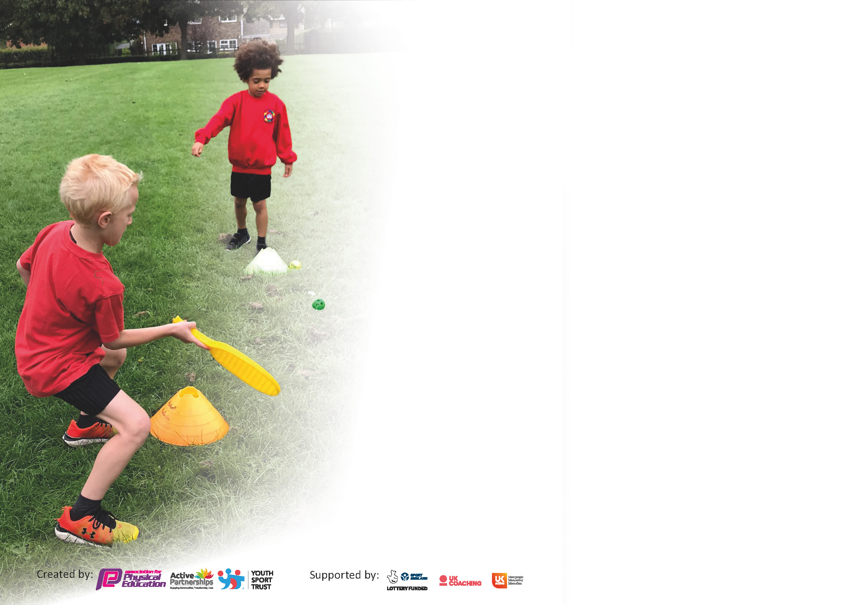

It is important that your grant is used effectively and based on school need. The Education Inspection Framework (Ofsted 2019 p64) makes clear there will be a focus on ‘whether leaders and those responsible for governors all understand their respective roles and perform these in a way that enhances the effectiveness of the school’.

Under the Quality of Education criteria (p41) inspectors consider the extent to which schools can articulate their curriculum (INTENT), construct their curriculum (IMPLEMENTATION) and demonstrate the outcomes which result (IMPACT).

To assist schools with common transferable language this template has been developed to utilise the same three headings which should make your plans easily transferable between working documents.

Schools must use the funding to make additional and sustainable improvements to the quality of Physical Education, School Sport and Physical Activity (PESSPA) they offer. This means that you should use
the Primary PE and sport premium to:

- Develop or add to the PESSPA activities that your school already offer
- Build capacity and capability within the school to ensure that improvements made now will benefit pupils joining the school in future years

Please visit gov.uk for the revised DfE guidance including the 5 key indicators across which schools should demonstrate an improvement. This document will help you to review your
provision and to report your spend. DfE encourages schools to use this template as an effective way of meeting the reporting requirements of the Primary PE and sport premium.

We recommend you start by reflecting on the impact of current provision and reviewing the previous spend.

Schools are required to publish details of how they spend this funding as well as on the impact it has on pupils’ PE and sport participation and attainment by the end of the summer term or by 31st July 2021 at the latest.

** In the case of any under-spend from 2019/20 which has been carried over this must be used and published by 31st March 2021.

We recommend regularly updating the table and publishing it on your website throughout the year. This evidences your ongoing self-evaluation of how you are using the funding to secure maximum, sustainable impact. Final copy must
be posted on your website by the end of the academic year and no later than the 31st July 2021. To see an example of how to complete the table please click HERE.
Created by: Supported by:

.
Key achievements to date until July 2025: | Areas for further improvement and baseline evidence of need:
PE curriculum successfully delivered in all Year groups  6 out of 13 teachers and their assistants received substantial CPD training by a professional sports education provider (Premier Education) for 2 complete half-term sessions. Teachers reported increases of confidence and that they learned a broader range of activities to help children to enhance and improve their PE skills. Teachers reported a clearer understanding of progression and how to steadily and systematically develop their class’s skills, understanding and tactical awareness.  All children throughout school given opportunities to take part in rigorous sports day events.  An after-school multi-sports club was offered free of charge for parents with the following breakdown:  Year 5/6 38 children took part during autumn term  Year ¾ 48 children took part during spring term  Year 1 / 2 38 children took part during the summer term  2 x basketball challenge matches were played against a nearby primary school. | We aim to continue with further CPD training from Premier Education’s qualified coaches so that teachers have more opportunities to develop their lessons and teaching skills in other areas of sport and PE; newest arrival teachers will be prioritised.  Dance is the next general target area for improving delivery of lessons.  Intend to continue this.  Intention is to set up frequent competitions and tournaments with a small group of other local primary schools.

Did you carry forward an underspend from 2024-25 academic year into the current academic year? NO

.
Academic Year: September 2024 to March 2025 | Total fund carried over: £0 | Date Updated: 2.7.25
What Key indicator(s) are you going to focus on? |  |  |  | Total Carry Over Funding:
 |  |  |  | £0
Intent | Implementation |  | Impact
Your school focus should be clear how you want to impact on your pupils. | Make sure your actions to achieve are linked to your intentions: | Carry over funding allocated: £0 | Evidence of impact: How can you measure the impact on your pupils; you may have focussed on the difference that PE, SS & PA have made to pupils re-engagement with school. What has changed?: | Sustainability and suggested next steps and how does this link with the key indicators on which you are focussing this academic year?:

Meeting national curriculum requirements for swimming and water safety.

N.B Complete this section to your best ability. For example you might have practised safe self-rescue techniques on dry land.
What percentage of your current Year 6 cohort swim competently, confidently and proficiently over a distance of at least 25 metres?  N.B. Even though your pupils may swim in another year please report on their attainment on leaving primary school at the end of the summer term 2021. | 25 %
What percentage of your current Year 6 cohort use a range of strokes effectively [for example, front crawl, backstroke and breaststroke]? | 25 %
What percentage of your current Year 6 cohort perform safe self-rescue in different water-based situations? | 35 %
Schools can choose to use the Primary PE and sport premium to provide additional provision for swimming but this must be for activity over and above the national curriculum requirements. Have you used it in this way? | No

Action Plan and Budget Tracking
Capture your intended annual spend against the 5 key indicators. Clarify the success criteria and evidence of impact that you intend to measure to evaluate for pupils today and for the future.

Academic Year: 2024/25 | Total fund allocated: £27381 | Date Updated: 2.7.25
Key indicator 1: The engagement of all pupils in regular physical activity – Chief Medical Officers guidelines recommend that primary school pupils undertake at least 30 minutes of physical activity a day in school |  |  |  | Percentage of total allocation:
 |  |  |  | %
Intent | Implementation |  | Impact | £15189.20 for Premier Education  = 15189.20/27381=55.5%
Your school focus should be clear what you want the pupils to know and be able to do and about  what they need to learn and to  consolidate through practice: | Make sure your actions to achieve are linked to your intentions: | Funding allocated: | Evidence of impact: what do pupils now know and what can they now do? What has changed?: | Sustainability and suggested next steps:
Children receive 2x planned and high-quality PE lessons per week (1 being an indoor topic the other being outdoor).  Lunch-time activities provided once a week by Premier Education | 4 class teachers received at least 1 full term of focused CPD training in delivering a PE topic of their choosing; 2 class teachers got a half term of focused CPD training in specific PE areas for teaching.  Lunch-time activities were offered for 1 hour on most Mondays of the whole year (except for 1st month). | £15189.20  Part of a lump sum of £15189.20 | Teachers have gained experience and confidence resulting in children having developed clear sense of physical routines and the process of how to learn new skills and what they need to do to improve them. | Hope to continue our partnership with Premier Education Group so that teachers can receive further CPD training in other PE areas.  (dance and gymnastics are areas to target across the school; in particular, making dance attractive to reluctant pupils.)
Key indicator 2: The profile of PESSPA being raised across the school as a tool for whole school improvement |  |  |  | Percentage of total allocation:
 |  |  |  | %
Intent | Implementation |  | Impact | Approx £2000 = 2000/27381= 7%
Your school focus should be clear what you want the pupils to know and be able to do and about  what they need to learn and to  consolidate through practice: | Make sure your actions to achieve are linked to your intentions: | Funding allocated: | Evidence of impact: what do pupils now know and what can they now do? What has changed?: | Sustainability and suggested next steps:
Children should expect and receive high quality PE lessons with clear paths of progression seen across the weeks but also across the years.  This should lead to high levels of performance whether it be in individual sports or in team games.  Progression is planned carefully across a topic so that chn have opportunities to learn, practice and develop the necessary skills for a team game and then build up to playing small group games leading up to more official refereed matches.  High quality sports equipment purchased.  Sports Day Activities  July 2024  (1 x Palmer Park  3x EYFS here at EPC)  July 2025  (1x River Academy  2 x EYFS, 1x Year 1, 1xYear 2 here at EPC) | In individual classes, due to the quality of PE lessons and the planned-in opportunities to develop and improve their skills, I have observed high levels of competitive skills during games where children have shown fabulous intensity, ability and tactical awareness as well as high levels of team-work.  EPC is particularly good at basketball and hockey but less good compared to other schools at football and long-distance running.  Materiel was purchased and ensured for all classes to have access to high quality sports equipment during their lessons (for instance each child had their own football, basketball, tennis racket, badminton racket, hockey stick etc.)  All year groups had opportunity to perform in competitive events with high levels of intensity and skill.  Year 6 and Year 5 pupils were given the opportunities to set out the sports events and activities and to experience organising and supervising sports for younger children and their peers including setting up, organising and running the event. | n/a  £1424.31  Supply cover for 3 events:  £633.55  Venue hire  £252.28  Transport (coaches)  £2880  TOTAL  £3765.83 | Our school has had notable success in basketball and hockey against other schools though has been weaker at football and running – this is primarily due to the small size of our playground and lack of sufficient space.  Clear progression is seen across the years of children’s understanding of a variety of sports and the rules to play them competitively.  Children arrived in Year 5/6 with the basic skills understood if not mastered with many children able to display excellent performance standards (in particular, basketball and hockey was played with a very high level of skill and intensity.)  The majority of children are able to display confident use of the equipment and can develop their skills at a personal pace until they are confident and can take part in team games more effectively.  Chn were able to compete at high standards and there were some very impressive individual performance in athletics event such as running, shot putt and long jump.  Chn demonstrated excellent understanding of the sports and very good awareness of how to communicate good sports habits and skills to younger children; they were able to encourage, motivate and inspire chn to perform to their best | To sustain this year’s high level of competitive matches against other schools..  Increasing children’s stamina is an area to improve as quite a large number of children appear to have sedentary lives and lifestyles at home. The lack of easy access to sports centres and open public spaces is also an issue in our school’s neighbourhood.  Need to continue to update existing stock (e.g. tennis balls/shuttlecocks, etc) and replace older, damaged equipment (e.g. footballs, broken basketballs etc)  Each class was able to experience approx. 4 x 15 minutes of targeted, quality sports events.  Experimenting with River Academy this year 2025 but with hope to return to Palmer Park for 2026 – depending on funding

Key indicator 3: Increased confidence, knowledge and skills of all staff in teaching PE and sport |  |  |  | Percentage of total allocation:
 |  |  |  | %
Intent | Implementation |  | Impact | Prem. Ed Group 51.2% (as before)
Your school focus should be clear | Make sure your actions to | Funding | Evidence of impact: what do | Sustainability and suggested
what you want the pupils to know | achieve are linked to your | allocated: | pupils now know and what | next steps:
and be able to do and about | intentions: |  | can they now do? What has
what they need to learn and to |  |  | changed?:
consolidate through practice:
Intention is for teachers to deliver high quality PE lessons that allow children to develop skills progressively and then be able to use these in a wide range of competitive and non-competitive events in teams or as individuals. | 6 class teachers + support staff received high quality sports training CPD from a professional Sports Company (Premier Education) for a whole academic term. | £15189.20 | Teachers have reported an increase in confidence at how to include progression in their teaching and in using a wider range of activities and techniques that allow children to improve their skills. | To be continued in the next year.  Newest/ least experienced teachers to be prioritised.  .
Key indicator 4: Broader experience of a range of sports and activities offered to all pupils |  |  |  | Percentage of total allocation:
 |  |  |  | %
Intent | Implementation |  | Impact | TLR, £2000  = 2000/27381 = 7%
Your school focus should be clear | Make sure your actions to | Funding | Evidence of impact: what do | Sustainability and suggested
what you want the pupils to know | achieve are linked to your | allocated: | pupils now know and what | next steps:
and be able to do and about | intentions: |  | can they now do? What has
what they need to learn and to |  |  | changed?:
consolidate through practice:
Additional achievements:  There were no swimming lessons this year due to previous year’s 2 year groups going.  We will return to the decision for Year 5s to go swimming in the next academic year (2025/2026) | N/A | N/A |  | Intention to deliver swimming lesson to Year 5 in the next academic year.  Bikeability is proving to be a difficult issue for us given the insufficient space and time available on the playground to run such a course; alternatives venues were looked at but none were suggested.

Key indicator 5: Increased participation in competitive sport |  |  |  | Percentage of total allocation:
 |  |  |  | N/A %
Intent | Implementation |  | Impact
Your school focus should be clear | Make sure your actions to | Funding | Evidence of impact: what do | Sustainability and suggested
what you want the pupils to know | achieve are linked to your | allocated: | pupils now know and what | next steps:
and be able to do and about | intentions: |  | can they now do? What has
what they need to learn and to |  |  | changed?:
consolidate through practice:
An after-school sports club was run every half-term of the year during which Year 5/6 had 2 half-terms; Year ¾ had 2 half terms and Year ½ had 2 half terms.  Other Events  To offer competitive events for children to take part in. | Chn were given opportunities to take part in a wide range of team games such as basketball, bench ball, dodgeball.  8 x basketball matches between staff and pupils ( a total of 48 pupils involved)  Year 6 Boys football v Thameside (9 pupils)  Year 5/6 Girls v Thameside (8 pupils)  Year 5 hockey v Thameside (9 pupils)  Year 4 football v Thameside (9 pupils)  Year 6 basketball v Emmer Green, Caversham Park (8 pupils)  Year 3 Gymnastics tourney v other schools (8 pupils)  Year 4 hockey v Thameside (10 pupils  Year 5 basketball v Thameside (8 pupils)  Year 5 Girls hockey v Thameside (8 pupils)  Year 6 Boys football v Cav Park (8 pupils)  Year 6 hockey v Thameside (8 pupils)  Year 2 athletics v other schools (8 pupils)  Year 3 football coaching session (18 pupils)  Year 5/6 cross-country race at Emmer Green (approx. 20 pupils)  Year 5 girls 2 x teams v Emmer Green (14 pupils)  Year 5/6 football 2 x teams (16 pupils) at St Anne’s  Year ¾ Rounders at St Anne’s (10 pupils)  Year 5/6 Cricket at St Anne’s (8 pupils)  Total:31 different teams in 25 separate events  Total pupils involved = 235 pupils | Part of Premier Education payment  N/A | 38 pupils from Year 5/6  48 pupils from Year ¾  38 pupils from Yaer 1 / 2  Total = 124 pupils  Total 31 teams sent to 25 separate events  Total 235 pupils involved in organised, competitive sports  Our school teams have been notably successful at basketball, gymnastics and hockey but less so at football and athletics/running.  The main factors for this is the small size of our playground – chn are not used to open spaces for playing in – and the resulting lack of sustained running this implies.  Our school cohort is, in general, not as fit as they should be due to the area being enclosed with few readily accessibly open spaces for play. I also suspect many families are quite housebound.  Another thing I noticed was that we were sending teams of all mixed abilities to events whereas other schools were often picking the same, best sports pupils.  . | To continue offering an after-school sports club as well as a football club, a martial arts club and other potential sports clubs.  To continue to offer a wide range of sports and matches for chn to attend.  A possibility is to pick 2 teams; one stronger and the other to give other children a chance to experience competitive sports.  .

Signed off by
Head Teacher:
Date:
Subject Leader: | Trevor Hearfield
Date: | 3.7.25
Governor:
Date:

