Our Beautiful World Autumn 1 – UKS2/LKS2/KS1 Science
Title of area of learning - Change For The Better?
The basic parts of the human body and associated senses
Prior Knowledge/ Prior Skills: | Future Learning
Use all their senses in hands-on exploration of natural materials. (Nursery - Humans)  Name and describe people who are familiar to them. (Reception - Humans) | •Describe how animals obtain their food from plants and other animals, using the idea of a simple food chain, and identify and name different sources of food. (Y2 - Living things and their habitats)  • Describe how living things are classified into broad groups according to common observable characteristics and based on similarities and differences, including microorganisms, plants and animals. (Y6 - Living things and their habitats)  • Give reasons for classifying plants and animals based on specific characteristics. (Y6 - Living things and their habitats)
Planned outcome:
- •• Identify, name, draw and label the basic parts of the human body and say which part of the body is associated with each sense.
Misconceptions
only four-legged mammals, such as pets, are animals • humans are not animals • insects are not animals
Learning to Assess
Humans have key parts in common, but these vary from person to person. Humans (and other animals) find out about the world using their senses. Humans have five senses – sight, touch, taste, hearing and smelling. These senses are linked to particular parts of the body
Possible Evidence
• Can play and lead ‘Simon says’
• During PE lessons, can follow instructions involving parts of the body
• Can label parts of the body on pictures and diagrams
• Can explore objects using different senses

Step 1 The Human Body  Identify, name, draw and label the basic parts of the human body.  To name and label the parts of the human body.  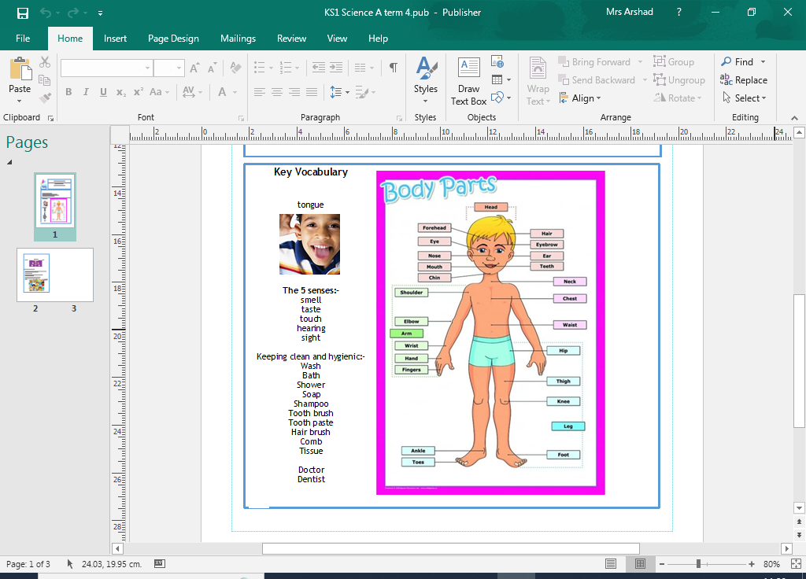  Step 2 The 5 Senses  Children will be able to name the 5 senses and know which body is associated with each of the senses. Ch will also be able to use their senses to compare different textures, smells and sounds.  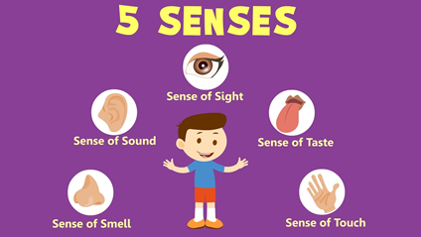  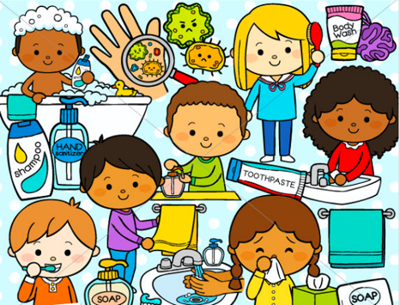 | Tiered Vocabulary  3  2  1  The 5 senses:-  smell taste touch hearing sight  tongue
Scaffolds/Enquiry Activities | Oracy Activities
• Make first-hand close observations of parts of the body e.g. hands, eyes.  • Compare two people.  • Take measurements of parts of their body.  • Compare parts of their own body.  • Look for patterns between people e.g. Do people with big hands have big feet?  • Classify people according to their features.  • Investigate human senses e.g. Which part of my body is good for feeling, which is not? Which food/flavours can I identify by taste? Which smells can I match? | • use first-hand close observations to make detailed drawings  • name body parts correctly when talking about measurements and comparisons e.g. “My arm is x straws long.” “My arm is x straws long and my leg is y straws long. My leg is longer than my arm.” “We both have hands, but his are bigger than mine.” “These people have brown eyes and these have blue.”  • talk about their findings from investigations using appropriate vocabulary e.g. “My fingers are much better at feeling than my toes” “We found that the crisps all taste the same.

