Healthy Body, Healthy Minds – UKS2/LKS2/KS1 Science
Title of area of learning –
Year 1 Spring 2 What are the basic needs of animals, including humans, for survival (water, food, air)?

Prior Knowledge/ Prior Skills: | Future Learning
• Identify and name a variety of common animals that are carnivores, herbivores and omnivores. (Y1 - Animals, including humans)  • Identify, name, draw and label the basic parts of the human body and say which part of the body is associated with each sense. (Y1 - Animals, including humans) | • Identify that animals, including humans, need the right types and amount of nutrition, and that they cannot make their own food; they get nutrition from what they eat. (Y3 - Animals, including humans)  • Describe the differences in the life cycles of a mammal, an amphibian, an insect and a bird. (Y5 - Living things and their habitats)  • Describe the life process of reproduction in some plants and animals. (Y5 - Living things and their habitats)  • Recognise the impact of diet, exercise, drugs and lifestyle on the way their bodies function. (Y6 - Animals, including humans)
Planned Outcome
• Notice that animals, including humans, have offspring which grow into adults.
• Find out about and describe the basic needs of animals, including humans, for survival (water, food and air).

Misconceptions
Some children may think:
• an animal’s habitat is like its ‘home’
• all animals that live in the sea are fish
• respiration is breathing
• breathing is respiration.

Assessment for Learning
Animals, including humans, have offspring which grow into adults. In humans and some animals, these offspring will be young, such as babies or kittens, that grow into adults. In other animals, such as chickens or insects, there may be eggs laid that hatch to young or other stages which then grow to adults. The young of some animals do not look like their parents e.g. tadpoles.
All animals, including humans, have the basic needs of feeding, drinking and breathing that must be satisfied in order to survive.

Possible Evidence
• Can describe how animals, including humans, have offspring which grow into adults, using the appropriate names for the stages
• Can state the basic needs of animals, including humans, for survival

Learning Journey – small steps in learning to meet the planned outcome  Step 1- Animal Offspring  Notice that animals, including humans, have offspring which grow into adults.  Identifying and classifying. To match, sort and group young animals and their adults.  Step 2 Life Cycles  Notice that animals, including humans, have offspring which grow into adults. Gathering and recording data to help in answering questions.  To find out how animals change as they grow into adults.  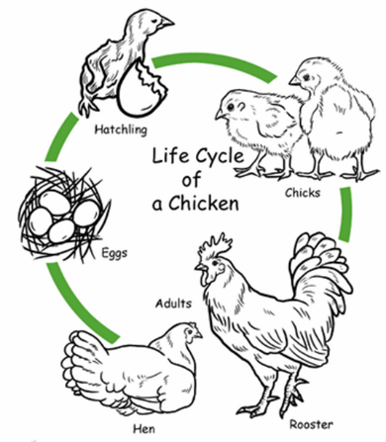  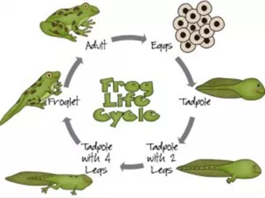  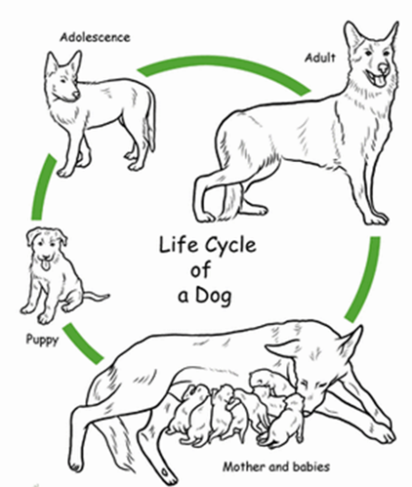  Step 3 Growing Up  Notice that animals, including humans, have offspring which grow into adults. Asking simple questions. Using their observations and ideas to suggest answers to questions.  To compare the stages of the human life cycle.  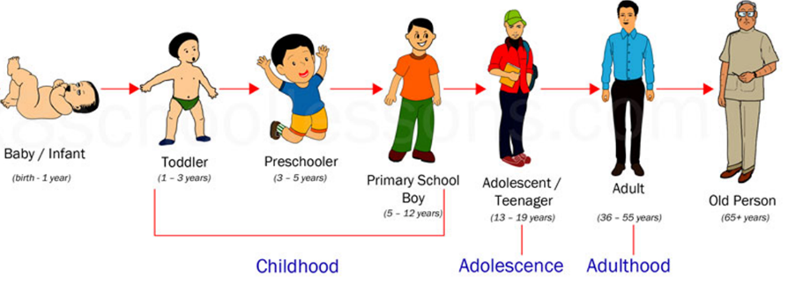  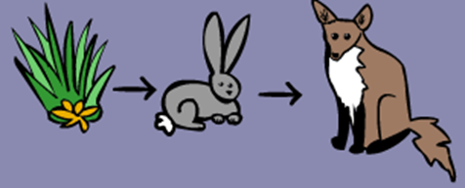  Step 4 Survival  Find out about and describe the basic needs of animals, including humans, for survival (water, food and air). Use their observations and ideas to suggest answers to questions.  To research and describe what animals, including humans, need to survive. | Tiered Vocabulary  offspring, reproduction life cycles  3  2  1  , growth, baby, toddler, child, teenager, adult, old person, names of animals and their babies (e.g. chick/hen, kitten/cat, caterpillar/butterfly), survive, survival, water  Human — a person  Survival - to live or exist  Nutrition—food necessary for food and growth  Life cycle - the series of changes in a life as an animal grows and develops and has young  Life stage— different part or time of a life  Change— become different  Different— not the same  Reproduce— to have young or babies  Shelter— somewhere to live  Baby—very young child  Toddler—a young child who is just learning to walk  Child - a young person  Teenager / adolescent - a person between 13 and 19 years of age  Adult - a person who is fully grown or developed  Elderly person—somebody of old age  Lamb - a young sheep  Calf —a young cow  Foal — a young horse  Piglet - a young pig  Chick - a young chicken or bird  Duckling - a young duck  Gosling - a young goose  Cygnet—a young swan  Puppy—a young dog  Kitten— a young cat  Cub - a young fox or animal like a lion  Tadpole — a young frog  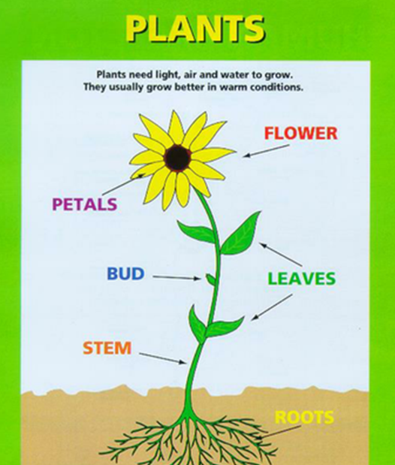
Scaffolds/Enquiry Activities | Oracy Activities
• Ask people questions and use secondary sources to find out about the life cycles of some animals.  • Observe animals growing over a period of time e.g. chicks, caterpillars, a baby.  • Ask questions of a parent about how they look after their baby.  • Ask pet owners questions about how they look after their pet. | • describe, including using diagrams, the life cycle of some animals, including humans, and their growth to adults e.g. by creating a life cycle book for a younger child  • measure/observe how animals, including humans, grow.  • Show what they know about looking after a baby/animal by creating a parenting/pet owners’ guide

