Where Would We Be Without Water? – UKS2/LKS2/KS1 Science
Title of area of learning –
Year 1 Spring 1 Identifying and naming common flowering plants and trees and their basic structures
Plants

Prior Knowledge/ Prior Skills: | Future Learning
• Plant seeds and care for growing plants. (Nursery – Plants)  • Understand the key features of the life cycle of a plant and an animal. (Nursery – Plants)  • Begin to understand the need to respect and care for the natural environment and all living things. (Nursery – Plants)  • Explore the natural world around them. (Reception – Living things and their habitats)  • Recognise some environments that are different to the one in which they live. (Reception – Living things and their habitats) | • Observe and describe how seeds and bulbs grow into mature plants. (Y2 - Plants)  • Find out and describe how plants need water, light and a suitable temperature to grow and stay healthy. (Y2 - Plants)  • Identify and name a variety of plants and animals in their habitats, including microhabitats. (Y2 - Living things and their habitats)  • Identify and describe the functions of different parts of flowering plants: roots, stem/trunk, leaves and flowers. (Y3 - Plants)  • Investigate the way in which water is transported within plants. (Y3 - Plants)
Planned outcome:
• Identify and name a variety of common wild and garden plants, including deciduous and evergreen trees.
• Identify and describe the basic structure of a variety of common flowering plants, including trees.
Misconceptions
Some children may think:
• plants are flowering plants grown in pots with coloured petals and leaves and a stem
• trees are not plants
• all leaves are green
• all stems are green
• a trunk is not a stem
• blossom is not a flower.
Learning to Assess
Growing locally, there will be a vast array of plants which all have specific names. These can be identified by looking at the key characteristics of the plant. Plants have common parts, but they vary between the different types of plants. Some trees keep their leaves all year while other trees drop their leaves during autumn and grow them again during spring.
Possible Evidence
• Can name trees and other plants that they see regularly
• Can describe some of the key features of these trees and plants e.g. the shape of the leaves, the colour of the flower/blossom
• Can point out trees which lost their leaves and those that kept them the whole year
• Can point to and name the parts of a plant, recognising that they are not always the same e.g. leaves and stems may not be green

Step 1  - identify and describe the basic structure of a variety of common flowering plants, including trees.  Step 2  • identify and name a variety of common wild and garden plants, including deciduous and evergreen trees  • identify and classify through sorting and grouping and explain my decisions.  Daisy, Dandelion, Buttercup, Rose, Daffodil, Crocus, Tulip, Poppy  Step 3  • identify and name a variety of common wild and garden plants, including deciduous and evergreen trees  Horse Chestnut (conker), Oak, Willow, Sycamore, Conifer, Pine  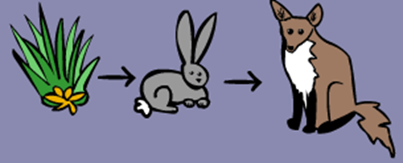  Step 4  - Identify changes across the 4 seasons.  Step 5  RIVER WALK | Tiered Vocabulary  Deciduous tress - these trees loose their leaves in winter  Evergreen trees- these trees keep their leaves all year round  3  2  1  Leaf, flower, blossom, petal, fruit, berry, root, seed, trunk, branch, stem, bark, stalk, bud Names of trees in the local area Names of garden and wild flowering plants in the local area  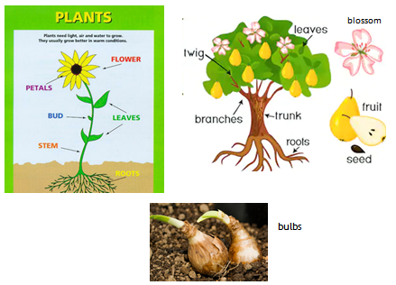  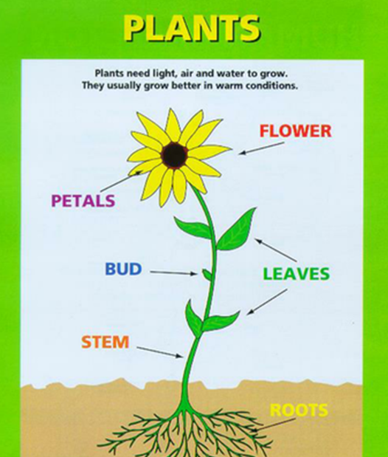
Scaffolds/Enquiry Activities | Oracy Activities
• Make close observations of leaves, seeds, flowers etc.  • Compare two leaves, seeds, flowers etc.  • Classify leaves, seeds, flowers etc. using a range of characteristics.  • Identify plants by matching them to named images.  • Make observations of how plants change over a period of time.  • When further afield, spot plants that are the same as those in the local area studied regularly, describing the key features that helped them. | •sort and group parts of plants using similarities and differences  • use simple charts etc. to identify plants  • collect information on features that change during the year  • use photographs to talk about how plants change over time

